GUILDFORD CRICKET FESTIVAL 2022

Surrey CCC v Leicestershire CCC

(Tuesday 2nd August - Royal London One-Day Cup)

CORPORATE MARQUEES AND MATCH DAY HOSPITALITY
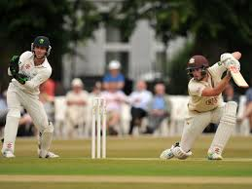
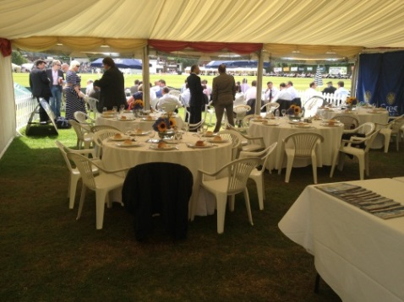
Corporate Marquee interior

Surrey cricket at Woodbridge Road

We are offering the usual Corporate Marquees and Corporate Hospitality packages on Tuesday 2nd August.
The options are:

- All-inclusive Marquee Package
This comprises your own private Marquee, 40 Ground Admission Tickets, 12 car park passes, morning coffee on arrival, a superb buffet luncheon with wine, traditional Guildford cricket tea, complimentary bar all day and match scorecards. High quality catering and staff ensure that guests are entertained in style.
The all-inclusive cost for 40 persons is £5,950 + VAT. Hirers taking the All-inclusive Package may add additional guests up to a maximum capacity of 50 persons in the marquee. The cost for each additional guest (including Ground Admission Ticket, catering and drinks) is £135 + VAT.

- All-inclusive Match Day Hospitality for Groups of 10 Persons

The package comprises 10 Ground Admission Tickets, 5 car park passes, morning coffee on arrival, a superb buffet luncheon with wine, traditional Guildford cricket tea, complimentary bar all day and match scorecard. Your group will be based for the day in a Marquee hosted by Guildford Cricket Club.
The all-inclusive cost for a group of 10 persons is £1,525 + VAT. Additional places may be booked at the pro rata rate of £152.50 + VAT per person.

Marquee facilities. Guildford Cricket Club provides high quality Marquees on the boundary edge at the Railway End of The Sports Ground. Every Marquee has a private covered area to the front with an excellent view of the cricket, with luncheon served inside. Marquees accommodate up to 50 persons. All interior and exterior furniture and catering facilities are provided.

Tickets, car park passes, ground maps, and general information will be issued to hirers in early May (subject to payment being received). This will give corporate hosts time to send out tickets, etc. to their guests.

Booking conditions - cancellation of the match or restrictions on spectators
All Marquee hires are subject to the Guildford Cricket Festival Booking Terms & Conditions (see www.guildfordcc.com).

Upon receipt of a completed Booking Form, written confirmation will be sent with an invoice for the full amount. Payment in full is required within 21 days.
The Government has announced the ending of all Covid-19 restrictions with effect from 27th January 2022. If restrictions were to be re-imposed resulting in the cancellation by Surrey CCC of either match or rules being imposed limiting spectators and preventing the operation of the corporate hospitality facilities, a 100% refund will be made by Guildford Cricket Club Limited to all those who have made bookings.

To make a booking, please complete and return the enclosed Booking Form. If you need assistance or further information on hiring Corporate Marquees or hospitality packages, please contact:
Chad Murrin, Commercial Manager, Guildford Cricket Club Limited
Mobile 07767 224632 E-mail: chad_murrin@msn.com

Guildford Cricket Festival 2022
Corporate Marquee and Match Day Hospitality Booking Form
Hirer’s Company Name
Address including postcode
Contact person and position
Telephone
E-mail
DATE | WHAT YOU ARE BOOKING | YOUR BOOKING
 |  | PRICE | TICK TO CONFIRM | AMOUNT YOU PAY
Surrey v Leicestershire Tuesday 2nd August | ALL-INCLUSIVE MARQUEE PACKAGE FOR 40 PERSONS | £5,950
 | ALL-INCLUSIVE MATCH DAY HOSPITALITY FOR 10 PERSONS | £1,525
ADD VAT @ 20% |  |  |  | £
 | If you require additional spaces, these will be invoiced separately. Call 07767 224632. |  | TOTAL COST |  |  |  |  | £
PAYMENT TERMS
Payment will be invoiced in full when the completed Booking Form is returned. Payment is due within 14 days.
 |  | I hereby acknowledge and accept the Guildford Cricket Festival Terms & Conditions |  |  |  | Return the Booking Form as soon as possible to secure your Booking. Please scan and send it by email to  chad_murrin@msn.com
 |  | Signature
 |  | Print name
 |  | Date
 |  | Call 07767 224632 or e-mail chad_murrin@msn.com if you have any questions

